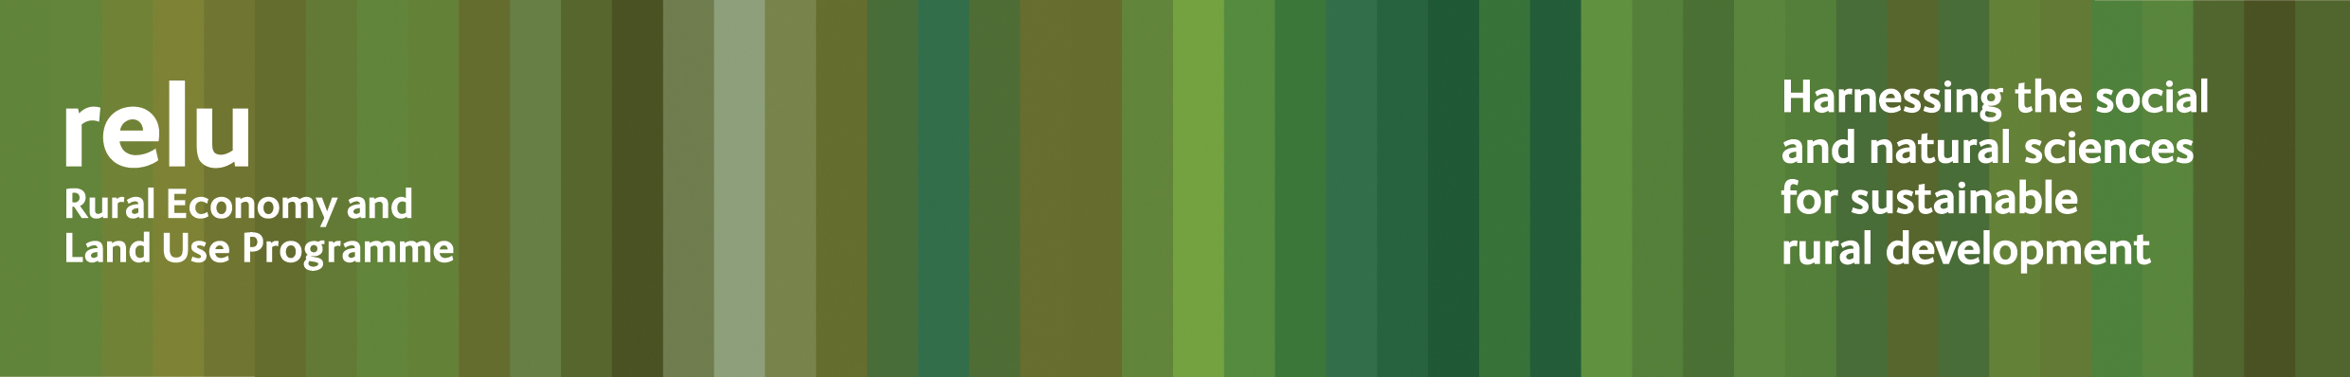

PRESS RELEASE

22 November 2010

A written charter for land use could underpin collaboration and integrated land management

A written charter for land use could support a “Big Society” approach and enable more integrated management of England’s natural resources, according to academics at the UK research councils’ Rural Economy and Land Use Programme.

They have responded to the Government’s recent consultation on the natural environment of England by advocating a charter that would:

- Establish a new set of aspirations for, and expectations of, the public sector, private sector and civil society in relation to our natural environment.
- Significantly shift thinking, creating an enabling framework for individual and collaborative action.
- Promote an integrated approach to managing England’s natural resources, so that all the dimensions of policy options are fully considered before decisions are made.
- Set out the rights, responsibilities and expectations of land managers and how these can be delivered through a combination of the market, voluntary self-regulation and action, state regulation, and public incentives.

Director of the Relu Programme Professor Philip Lowe said: “Land in the UK and the natural resources that it supports – food production, biodiversity, clean water, carbon storage - are under more and more pressure, but are increasingly important to ensure our very survival in an era of climate change.

“Research carried out by interdisciplinary teams within the programme shows how effective collaborative action among landowners and other stakeholders can be in getting best value from these vital assets, by promoting an integrated approach. A written charter would clarify the framework that we need to support this.”

Download “Shaping the Nature of England: policy pointers from the Relu programme” from the Relu website at http://www.relu.ac.uk/news/briefings/BRIF13/NatureofEngland.pdf

Notes for editors:

- The Rural Economy and Land Use Programme is an interdisciplinary collaboration between the Economic and Social Research Council (ESRC), the Biotechnology and Biological Sciences Research Council (BBSRC) and the Natural Environment Research Council (NERC), with additional funding provided by the Scottish Government and Defra.
- More information about the Relu programme may be found at www.relu.ac.uk and “Shaping the Nature of England: policy pointers from the Relu programme may be downloaded from the website at http://www.relu.ac.uk/news/briefings/BRIF13/NatureofEngland.pdf
- For more information contact Anne Liddon, Science Communications Manager, tel 0191 222 6903 email anne.liddon@ncl.ac.uk.

ends

